**Lab Statement 1: Capturing FTP packets using Wireshark**

The control messages in FTP are sent on port 21. i.e what files are needed where they are located and size etc.

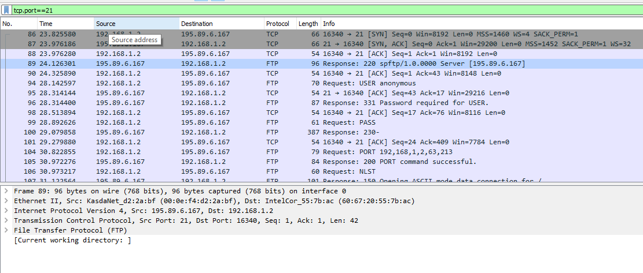

Whereas the files are sent and received on port 20.

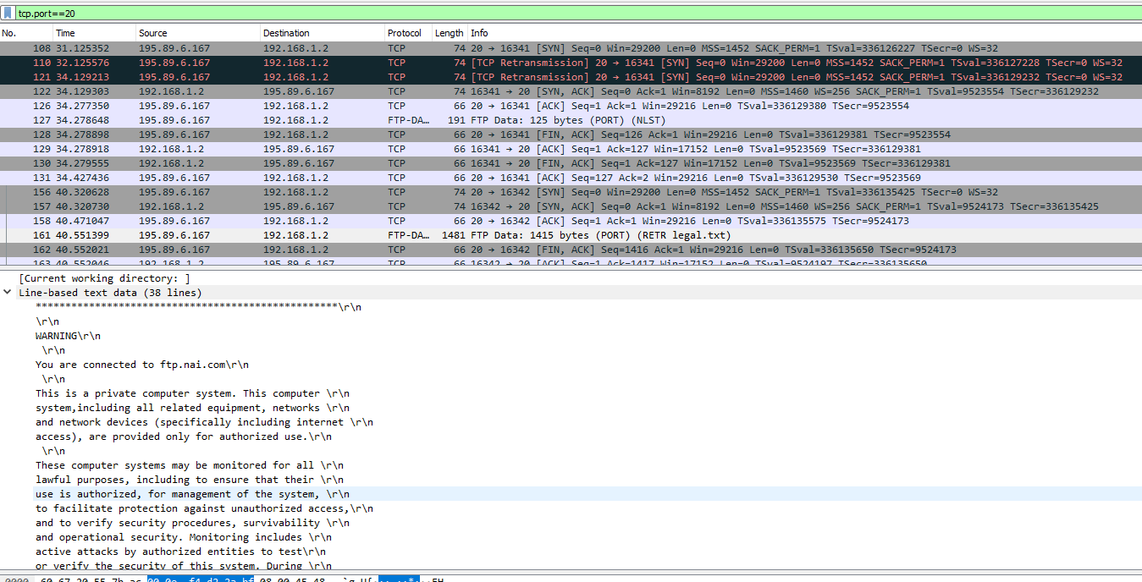

**Part 2:**

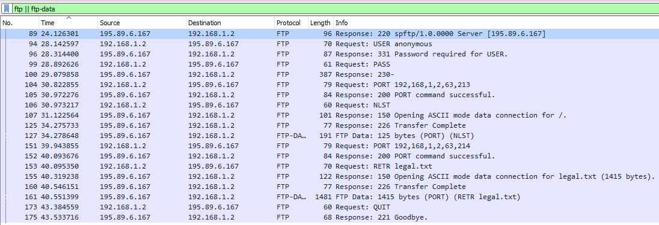

**Packet 89:** The response of the server on Command line request. The status code 220 means server is READY to receive messages and communicate. i.e. the TCP connection is established successfully

**Packet 94:** The user sends USERNAME anonymous for authentication. The command USER specifies that this request contains username

**Packet 96:** The server looks through its system, verifies username therefore sends status code 331 (which means the username is correct) and asks for password

**Packet 99:** The user sends PASS command and no argument which means password is NULL

**Packet 100:** The sever successfully authenticates the user and therefore send status code 230.

**Packet 104:** The PORT command is sent by an FTP client to establish a secondary connection (address and port) for data to travel over. i.e. Client asks server to send the data on IP:192.168.1.2 and Port:16341

**Packet 105:** Sever respond that as the result of port command the new connection has been established successfully.

**Packet 106:** The client asks for list of available files and directories.

**Packet 107:** 150 status code indicates File status okay and server is about to open data connection.

**Packet 125:** A 226 status code is sent by the server before closing the data connection after successfully processing the previous client command affecting the data connection. In most cases, it signals the completion of a file transfer

**Packet 127:** The server sends the data requested in pack 106. i.e the list of files and directories

**Packet 151:** The PORT command is sent by an FTP client to establish a secondary connection (address and port) for data to travel over. i.e. Client asks server to send the data on IP:192.168.1.2 and Port:16342

**Packet 152:** Sever respond that as the result of port command the new connection has been established successfully.

**Packet 153:** The user asks to retrieve the file “legal.txt”

**Packet 155:** 150 status code indicates File status okay and server is about to open data connection

**Packet 160:** A 226 status code is sent by the server before closing the data connection after successfully processing the previous client command affecting the data connection. In most cases, it signals the completion of a file transfer

**Packet 161:** The server sends data i.e. file named “legal.txt” as the result of command in Packet 153

**Packet 173:** The user asks to end the session

**Packet 175:** The server ends the connection and send status code 221